Minutes of Goshen Historical Society Meeting
April 29, 2025

The meeting began just after 6:22 pm due to the weather. Those present J.B. Hogan, Jana Vanderburg, Max Moore, Ralph Rathbun, Russell Gayer, Betsy McCoy, Bernadette Boyle, Doyle Smith, and Donnie Smith.

Jana Vanderburg gave an excellent “Living Historian” presentation of the roles of women during WW II. Women stepped into positions left behind when the men went to war. They were encouraged to join the war effort by filling victory jobs and posters showed Rosie the Riveter with the logo “We Can Do It.” Over 350,000 American women served in the US Military as WAC’s (Women’s Army Core), WAVES (Women Accepted for Volunteer Emergency Service in the Navy), SPAR’s (Coast Guard - Semper Paratus - Always Ready) and WASP’s (Women Airforce Service Pilots).

Women on the home front were instructed to grow victory gardens requiring one acre of land. Photos showed perfectly lined rows of vegetables and where each type of vegetable needed to be planted to flourish. The vegetables were canned because of war time rationing so families needed to Make Do for Victory. Each family was limited to one egg per person per week, 4 oz bacon, 1 oz cheese, 4 oz butter, 8 oz sugar and 2 oz tea. Expectant mothers were permitted to have oranges. Women also were taught how to knit, crochet and to sew. With a shortage of cotton material, clothing had to be repaired, reused, and repurposed. Jana attributes to the hemlines being raised because clothing was well worn or handed down.

Max Moore had an original War Bond stamp album and card that showed a family was able to purchase 5 War Bonds. He said War Bonds cost $18.70 to purchase and when redeemed they were worth $25. Children were instructed in school to tell their families to purchase these War Bonds. Advertisements to buy War Bonds appeared on glass milk jugs. Still recovering from the Depression, many families were just getting by, but they could help with scrap metal drives. Max said unfortunately, a lot of the metal collected was not of the best quality. Automobiles purchased during WW II or after did not come with bumpers or had wooden bumpers.

Jana invited everyone to attend the Home Front Heroes Day, Friday, May 9, 2025, from 9 am – 4 pm held at the Arkansas Airport-Drake Field. She explained her outfit which included a cotton dress, belt, hose with the line in the back, gloves of the 1940’s period had cuffs or were longer and women always wore a fashionable hat in public. “Snoods” were a type of heavy hairnet worn by women working in the factory but became popular even with famous movie stars as a way of protecting their hair while they worked. Jana crocheted a snood using material, crochet needles and a pattern from the 1940s. Jana showed us a small red flag with a blue star that families proudly hung in their windows. The number of blue stars represented the number of family members fighting in WW II. Flags with a gold star meant the military member was killed in battle.

Betsy McCoy talked about her Uncle Loyd Smith from Mayfield, AR, who served as an airplane mechanic at Luke Field in Arizona. He made friends with a civilian mechanic, Mrs. Margaret Garber. She and her husband Al invited Loyd and a friend from Minnesota to spend holidays and time off with

their families. During the mid-1960’s, Al and Margaret Garber visited Arkansas. The two families are now in their 3rd and 4th generations and remain friends.

Russell Gayer invited everyone to join the Washington County Historical Society with senior membership only costing $25.00. You would receive quarterly publications of Flashback journal that contains articles written by our very own Russell Gayer and J.B. Hogan. Russell also brought several old newspapers, one from Tulsa and the other, 1974 Northwest Arkansas Times that contained an article on Theresa Paschal becoming the 1974 Junior Rodeo Queen.

Next meeting is scheduled for Tuesday, July 29 at 6:00 pm.

Bernadette Boyle, Secretary

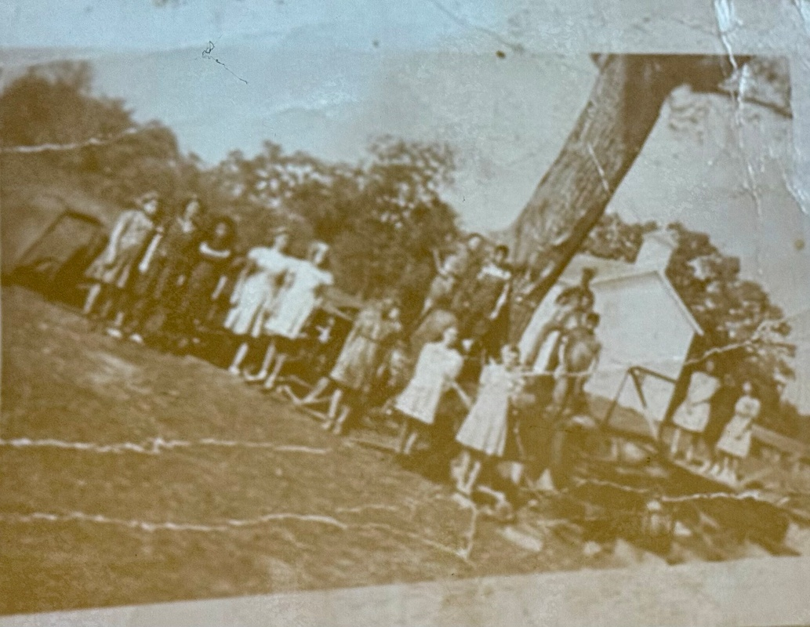

Goshen School
Junk Drive
WW II

1st Left-Merlene Starnes 2nd Left-Virginia Langham
4th from Left-Ola Hash (Norm & Elsie’s Daughter)
5th from Left-Betty Ruth Langham (Haid & Myrtie’s Daughter)
James Starnes (overalls in front of tree) Junior/Ray Jr. Starnes to Jame’s right

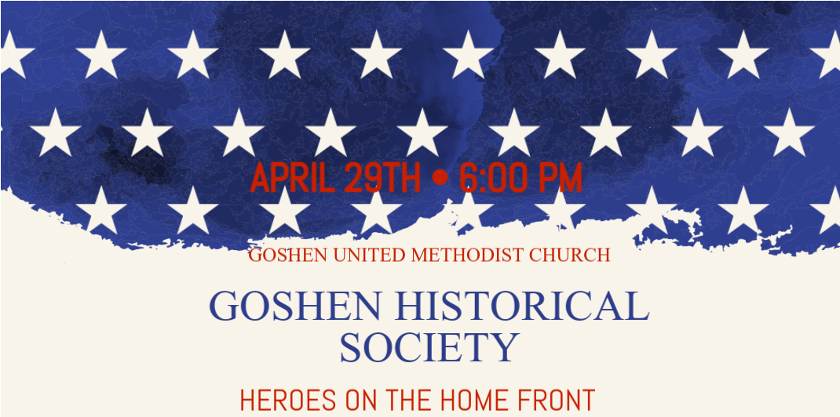

Presentation by Jana Vanderburg, “Living Historian”
